

**TO WHOM IT MAY CONCERN**

**It is certified that Mr. <Name> <fname> worked in Doosan 2800 MW Rabigh 2 Power Plant as a <Designation> from <From> to <To>.**

**During his stay in our organization we found him hard working and having a good moral character. We have no objection on his doing work at any where.**

**We wish him best of luck for his success in his future life.**

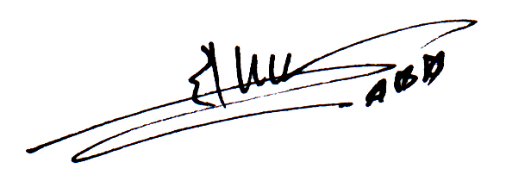

**HR Manager**